–

**AICT Project**

**Bite Burst (Food Website)**

Areej Sajid 241436

Anas Raheem 241374

Muhammad Ibrahim 241438

# Table of Contents

### 

# Introduction ......................................................... 3

# Requirement Analysis .................... 4

# Design Approach ......................................... 5

# Technologies Used .........................................6

# Implementation Details ................................................7-9

# Screenshots ..........................................10-12

# Challenges and Solutions ..............................................13

# Conclusion ...........................................14

# References ........................................... 14

**Project Title: Bite Burst (food website)**

**Introduction**

Food has always been a trending topic, so our group decided to create a food brand website named “Bite Burst.” We also observed that these websites are used daily, and we can say that they are one of the most used websites.

The goal of this project is to develop a user-friendly and interactive website for a food brand, which is essential for successfully engaging customers in today's digital landscape. The website will serve as a one-stop platform for customers to explore the brand’s offerings and place orders easily.

One of the main challenges it addresses is the fragmented online presence that many food brands struggle with, often resulting in lost chances to connect with and keep customers. This new website aims to change that by featuring an appealing menu display, intuitive navigation, options for customer feedback, and updates on promotions. By creating a smooth online experience, it will boost customer satisfaction and also provide the brand with valuable insights about customer preferences through feedback and analytics.

**Requirement Analysis**

**Functional Requirements**

**1. User Registration/Login System:**

Allow users to create accounts or log in using email/password.

**2. Menu Browsing and Search:**

Customers can search and filter items by category.

**3. Online Ordering System:**

Includes cart, order summary, and checkout functionality.

**4. Feedback and Rating System:**

Customers can leave feedback on products or services.

**5. Responsive Design:**

The website is mobile and tablet-friendly.

**Non-Functional Requirements**

**1. Performance:**

The website should load within 4 seconds under standard internet conditions.

**2. Security:**

Ensure secure handling of payment information and prevent unauthorized

access.

**3. Usability:** The design should prioritize intuitive navigation and clear instructions.

**Design Approach**

The design of the food brand website is centered around providing an intuitive and visually appealing user experience. The structure includes the following key elements:

1. **Layout**:
   * **Home Page**: The landing page introduces the brand with a clean, modern design, featuring a prominent banner image, catchy tagline, and links to other sections.
   * **Navigation Bar**: A fixed navigation bar at the top of every page ensures easy access to key sections like Home, Menu, About , and Contact.
   * **Footer**: A consistent footer provides quick links, social media icons, and brand contact details.
2. **Navigation Flow**:
   * The navigation is designed to be **user-friendly**, with links that direct users seamlessly to various sections of the website.
   * Each section is interconnected to enable smooth transitions, encouraging users to explore the menu, learn about the brand, or provide feedback.
3. **Visual Elements**:
   * The color scheme aligns with the brand's identity, creating a cohesive and appealing look. We used two appealing colors RED and YELLOW (which we think is a very good combination) which will give our website a very professional look.
   * The layout prioritizes responsiveness, ensuring the site adapts seamlessly to different devices, including desktops, tablets, and smartphones.

**Technologies Used**

The website was developed using the following tools and technologies:

1. **HTML (Hyper Text Markup Language):**
   * Used for structuring the website's content, including text, images, and links.
2. **CSS (Cascading Style Sheets):**
   * Used for styling and enhancing the visual design, including layout adjustments, colors, and typography.
   * Includes responsive design techniques like media queries to make the website mobile and tablet-friendly.
3. **JavaScript**:
   * Adds interactivity, such as dynamic menu toggles, form validation, and animations.
   * Enhances user experience by enabling features like hover effects.
4. **Bootstrap as CSS framework**
5. **FontOwesome for Icons**
6. **Unaplash for Images**
7. **Canva for UI Designing**

These technologies work together to create an engaging, efficient, and accessible web solution for the food brand.

**Implementation Details**

The food brand website includes several key features designed to enhance user engagement and deliver a seamless browsing experience.

1. **Responsive Design**
   * **Feature**: The website adapts seamlessly to different screen sizes, ensuring usability on desktops, tablets, and smartphones.
   * **Development**:
     + Implemented using **CSS media queries** to adjust the layout and design for various devices.
2. **Interactive Navigation Bar**
   * **Feature**: A fixed navigation bar provides links to all major sections (which include home, menu, About, and contact) allowing users to move effortlessly across the site.
   * **Development**:
     + Developed using **HTML** for structure and **CSS** for styling, with hover effects for better user feedback.
     + JavaScript was used to highlight the active page dynamically.
3. **Prominent Home Page Banner**
   * **Feature**: The homepage showcases a visually appealing banner that highlights the brand’s identity and core message.
   * **Development**:
     + Created using **HTML** and styled with **CSS** to include captivating typography and background images.
     + Transition effects for smooth scrolling and hover animations were added with **CSS**.
4. **Menu Section**
   * **Feature**: A dedicated section displays the brand's food offerings, with categories and descriptions for user convenience.
   * **Development**:
     + Structured with **HTML tables or div elements** for easy organization.
     + **CSS** styling enhances the visual presentation with custom fonts, borders, and spacing.
5. **Contact Form**
   * **Feature**: Users can reach out to the brand via a form to share inquiries, feedback, or suggestions.
   * **Development**:
     + Designed with **HTML forms**, including input fields for name, email, and message.
     + **JavaScript** was used to validate the form to ensure proper input from users before submission.
6. **Footer with Social Media Links**
   * **Feature**: A footer provides quick access to the brand’s social media pages, enhancing user connectivity.
   * **Development**:
     + Developed using **HTML** for structure and **CSS** for styling.
     + Icons were added using libraries like **Font Awesome** for a polished look.
7. **Feedback Mechanism**
   * **Feature**: Users can provide feedback about the brand or website via an embedded form or email link.
   * **Development**:
     + Implemented with **HTML** for form structure, validated with **JavaScript**, and styled with **CSS**.
8. **Search bar:**

**Feature:** The search bar allows users to quickly find specific food items on the website by entering keywords. It enhances usability by reducing the time spent navigating through the menu.

**Development**:

* + **HTML:** A search input field was created using <input> tags, placed within the navigation bar or a dedicated section on the website for accessibility.
  + **CSS**: Styled to blend seamlessly with the overall design of the website, using custom borders, colors, and icons for a polished look.

### ****Add to Cart****

#### **Feature**:

The Add to Cart feature allows users to select multiple items for purchase and view their selections in a cart. This improves user convenience by streamlining the ordering process.

#### **Development**:

* **HTML**:
  + Created "Add to Cart" buttons for each menu item using <button> elements.
  + Added a separate cart section to display selected items and their quantities.
* **CSS**:
  + Styled the buttons and cart section for visual consistency with the website's theme.
  + Used hover effects to enhance interactivity.

**Our website**

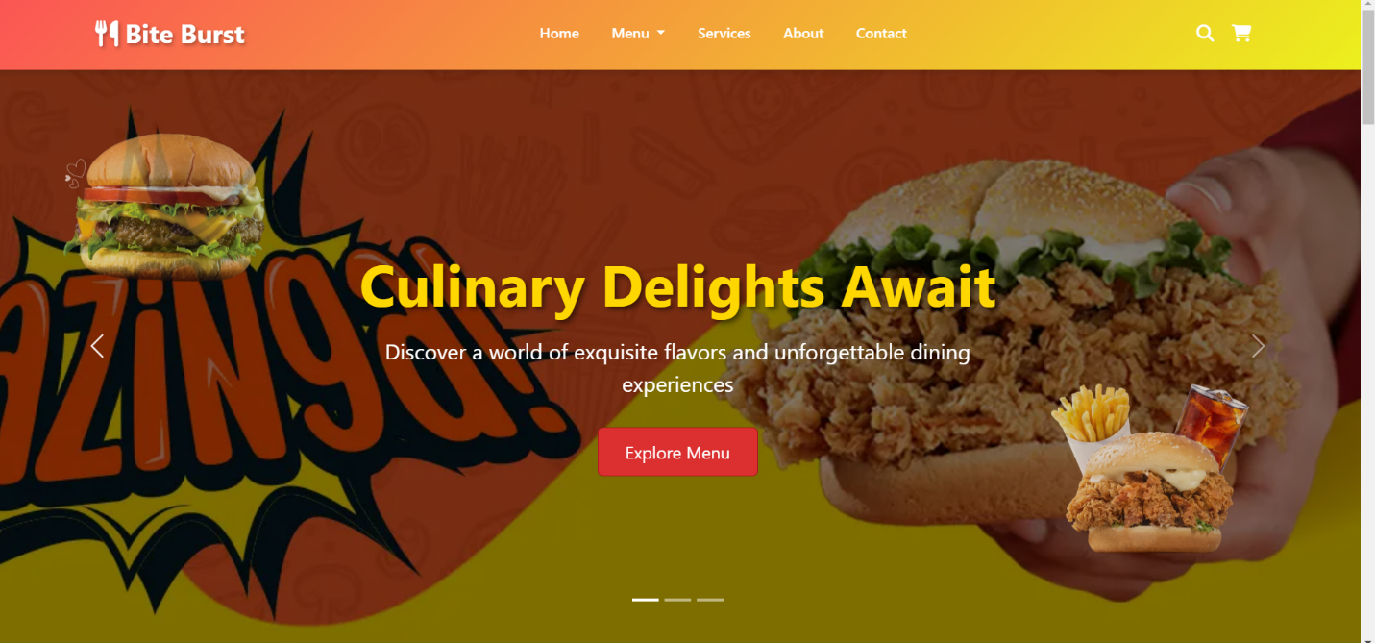

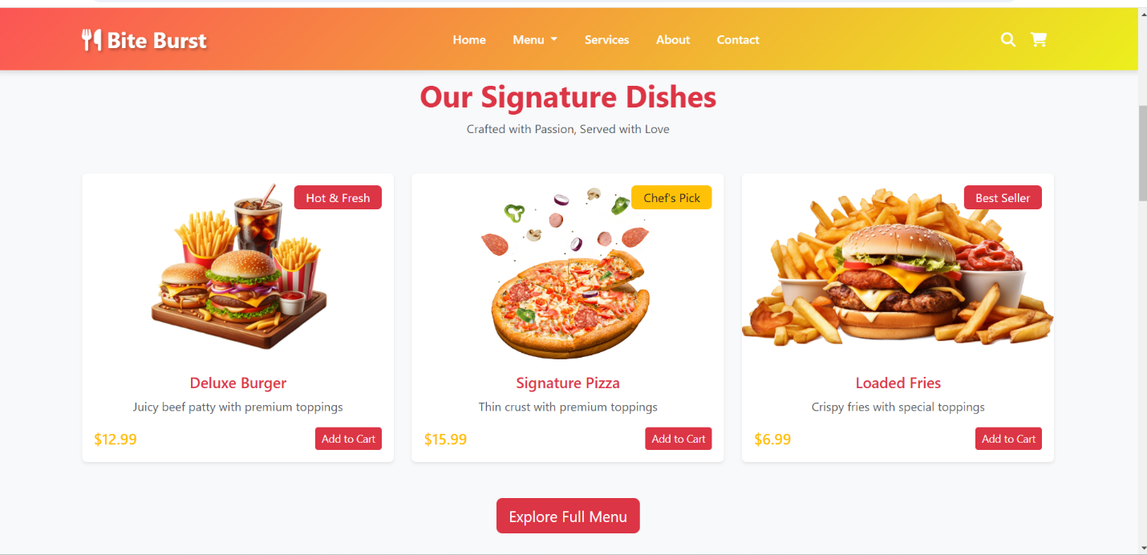

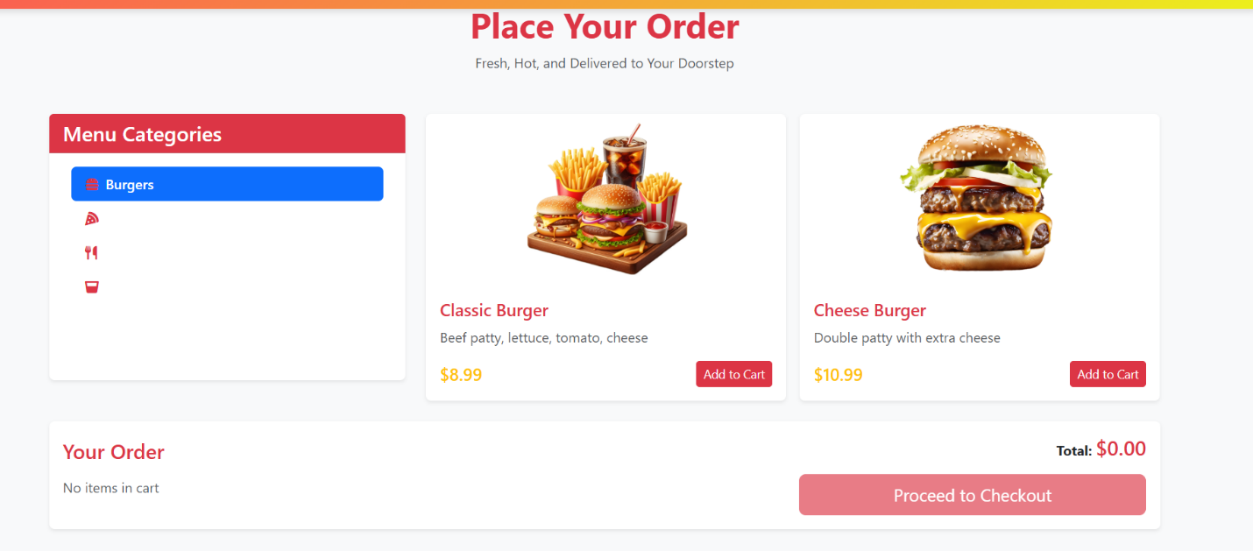

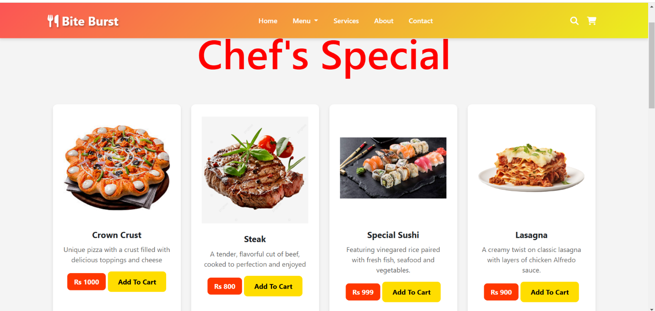

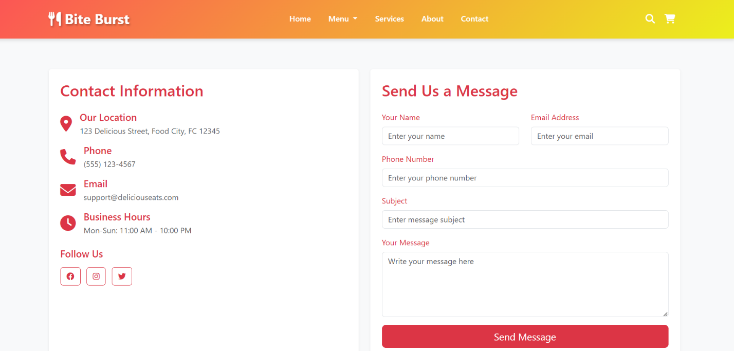

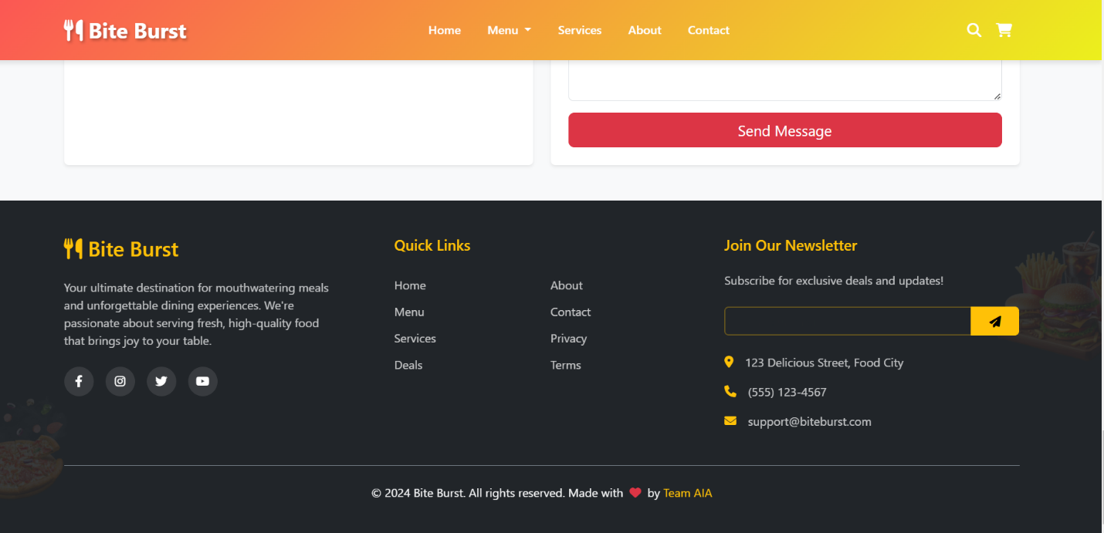

**Challenges and Solutions**

### ****Problem We Faced****

During the development of our website, we encountered a significant issue with code repetition. Elements such as the navigation bar and contact information, which appeared consistently across multiple pages, had to be manually duplicated in the HTML code for each page. The codebase became unmanageable and repetitive. This increased the likelihood of inconsistencies when users updated or modified elements.

### ****Solution We Found****

To address this problem, we implemented a modular approach by creating reusable components in our JavaScript code. Specifically:

* **Component-Based Design**:
  + We developed a **navigation bar component** and a **footer component** containing the contact information.
  + These components were defined as reusable functions or templates in JavaScript, encapsulating the HTML structure and styling.
* **Dynamic Insertion**:
  + Using JavaScript’s **DOM manipulation methods**, these components were dynamically inserted into the appropriate sections of every page during runtime.
* **Centralized Updates**:
  + This approach ensured that any updates or changes to the navigation bar or contact information could be made in a single place within the JavaScript code. The changes would then automatically reflect on all pages of the website.

**Conclusion and references:**

### ****Learning Outcomes****

Working on the development of this website was an incredibly valuable experience that deepened our understanding of web development. Here’s what we took away from the project:

**1. Technical Skills:**

We gained a strong grasp of essential web technologies like HTML, CSS, and JavaScript, learning how to combine them to craft functional and visually appealing websites.

We also learned how to implement responsive design techniques, making sure our site works well on various devices and screen sizes.

**2. Problem-Solving:**

Throughout the project, we encountered real-world challenges, such as code repetition, and tackled them by applying modular design principles. Our skills in debugging and optimizing web applications improved significantly.

**3. Project Management:**

We discovered how crucial it is to plan and organize our tasks, from the initial layout design all the way to feature implementation. We practiced version control and collaborative development, which helped our team work smoothly together and integrate different parts of the website effectively.

**4. User-Centric Design:**

We centered our efforts on creating a great user experience by optimizing navigation, interactivity, and responsiveness. We found that gathering user feedback was essential for making improvements along the way.

All in all, this project was a well-rounded learning experience that not only built our technical skills but also enhanced our problem-solving abilities. These are vital tools as we take on more complex web development projects in the future.

**References:**

* W3Schools
* Bootstrap Website
* MDN Docs
* Github
* Stackover Flow
* ChatGPT
* Web.dev